**Human Computer Interaction Important Questions with Solution**

1. **Define HCI. Why do we need to study HCI?**

**Definition:**

**HCI** (**human-computer interaction**) is the study of how people interact with computers and to what extent computers are or are not developed for successful interaction with human beings. A significant number of major corporations and academic institutions now study **HCI**.

**Why we need to study HCI:**

1. **Human**–**computer interaction** researches the design and use of **computer** technology, focused on the interfaces between people and **computers.**
2. HCI helps to build beautiful and novel interfaces are artistically pleasing and capable of fulfilling the tasks required.
3. We may call HCI as a marriage of art and science into a successful whole.
4. In order to design something for someone, we need to understand their capabilities and limitations.
5. We need to know if there are things that they will find difficult or, even, impossible.
6. It will also help us to know what people find easy and how we can help them by encouraging these things.
7. Human psychology is cognitive psychology. So, by studying HCI we know how humans perceive the computers and its technologies.
8. HCI let us know how people physically manipulate objects.
9. HCI inform us how humans store and process information and solve problems.
10. Cognitive psychology closely related with designing and building interactive computer systems.
11. **What are the skill needed to produce an effective design?**

**Skill needed of an Effective Design:**

* **Psychology and cognitive science** - to give his knowledge of the user’s perceptual, cognitive and problem-solving skills.
* **Ergonomics** - for the user’s physical capabilities.
* **Sociology** - to help her understand the wider context of the interaction.
* **Computer science and engineering** – to be able to build the necessary technology.
* **Business** - to be able to market it.
* **Graphic design** - to produce an effective interface presentation.
* **Technical writing** - to produce the manuals.
* **All side input** - It is not possible to design effective interactive systems from one discipline in isolation. Input is needed from all sides.

1. **Which components of computer are concern of HCI?**

Systems analysis has traditionally concerned itself with the influence of technology in the workplace and fitting the technology to the requirements and constraints of the job.

In the context of the user’s task and work HCI involves:

* The design of interactive systems.
* Implementation in interactive systems.
* Evaluation of interactive systems.

The other concern of HCI are:

1. **Visual Based:** The visual based human computer inter-action is probably the most widespread area in Human Computer Interaction (HCI) research.
2. **Audio Based:** The audio-based interaction between a computer and a human is another important area of in HCI systems. This area deals with information acquired by different audio signals.
3. **Task environment:** The conditions and goals set upon the user.
4. **Machine environment:** The environment that the computer is connected to, e.g. a laptop in a college student's dorm room.
5. **Areas of the interface:** Non-overlapping areas involve processes of the human and computer not pertaining to their interaction. Meanwhile, the overlapping areas only concern themselves with the processes pertaining to their interaction.
6. **Input flow:** The flow of information that begins in the task environment, when the user has some task that requires using their computer.
7. **Output:** The flow of information that originates in the machine environment.
8. **Feedback:** Loops through the interface that evaluate, moderate, and confirm processes as they pass from the human through the interface to the computer and back.
9. **Fit:** This is the match between the computer design, the user and the task to optimize the human resources needed to accomplish the task.
10. **What do you mean by the myth “3U” in HCI?**

**Myth:**

There are three ‘use’ words that must all be true for a product to be successful. “3U” comes from these 3 “use”.

They are:

* **Useful** – accomplish what is required: play music, cook dinner, format a document;
* **Usable** – do it easily and naturally, without danger of error, etc.;
* **Used** – make people want to use it, be attractive, engaging, fun, etc.

1. **What do you mean by the User, Computer and Interaction?**

**User:**

By user we may mean

* An individual user,
* A group of users working together, or
* A sequence of users

in an organization, each dealing with some part of the task or process.

The user is whoever is trying to get the job done using the technology.

**Computer:**

By computer we mean

* Any technology ranging from the general desktop computer to a large-scale computer system,
* A process control system or
* An embedded system.

The system may include non-computerized parts, including other people.

**Interaction:**

By interaction we mean

* Any communication between a user and computer, be it direct or indirect.
* Direct interaction involves a dialog with feedback and control throughout performance of the task.
* Indirect interaction may involve batch processing or intelligent sensors controlling the environment.
* The important thing is that the user is interacting with the computer in order to accomplish something.

1. **Clearly explain the “Laws of size Constancy”.**

**Laws of size Constancy:**

* The visual angle of an object is reduced as it gets further away, we might expect that we would perceive the object as smaller.
* In fact, our perception of an object’s size remains constant even if its visual angle changes.
* Same as a person’s height is perceived as constant even if they move further from us.

This is the *law of size constancy, and* it indicates that *our perception of size relies on factors* other than the visual angle.

1. **Define the term “Visual Acuity”.**

**Visual acuity:**

* Visual acuity is the ability of a person to perceive fine detail.
* Person with normal vision can detect a single line if it has a visual angle of 0.5 seconds of arc. Spaces between lines can be detected at 30 seconds to 1 minute of visual arc.

These represent the limits of human visual acuity.

1. **What is Fitts Law?**

**Fitts Law:**

* Fitts Law describes the time taken to hit a screen target:

Mt = a + b log2(D/S + 1)

where:

a and b are empirically determined constants

Mt is movement time

D is Distance

S is Size of target

* targets as large as possible  
  distances as small as possible

1. **Describe different types of reasoning with example.**

**Reasoning are 3 types:**

* 1. Deduction
  2. Induction
  3. Abduction

**Description of the various reasoning is given below:**

1. **Deductive Reasoning:**

* Deduction:
  + derive logically necessary conclusion from given premises.

e.g. If it is Friday then she will go to work

It is Friday

Therefore, she will go to work.

* Logical conclusion not necessarily true:

e.g. If it is raining then the ground is dry

It is raining

Therefore, the ground is dry

* When truth and logical validity clash:

e.g. Some people are babies

Some babies cry

Inference - Some people cry

1. **Inductive Reasoning:**

* Induction:
  + generalize from cases seen to cases unseen
  + e.g. all elephants we have seen have trunks  
     therefore all elephants have trunks.
* Unreliable:
  + can only prove false not true
* … but useful!
* Humans not good at using negative evidence
  + e.g. Wason's cards.

1. **Abductive Reasoning:**

* Reasoning from event to cause

e.g. Sam drives fast when drunk.

If I see Sam driving fast, assume drunk.

* Unreliable:

can lead to false explanations

1. **What is problem solving theory? Mention some of the theories and explain one of them.**

**Problem Solving:**

Process of finding solution to unfamiliar task using knowledge.

**Several Theories of problem solving:**

1. Gestalt
2. Problem space theory
3. Analogy
4. Skill acquisition

Explanation one of them:

**Problem space theory:**

* + problem space comprises problem states
  + problem solving involves generating states using legal operators
  + heuristics may be employed to select operators  
     e.g. means-ends analysis
  + operates within human information processing system  
     e.g. STM limits etc.
  + largely applied to problem solving in well-defined areas  
     e.g. puzzles rather than knowledge intensive areas

1. **What are the difference between Long-Term Memory and Short-Term Memory?**

|  |  |
| --- | --- |
| **Long Term Memory** | **Short Term Memory** |
| Repository for all our knowledge | Scratch-pad for temporary recall. |
| Slow access ~ 1/10 second | Rapid access ~ 70ms |
| Slow decay | Rapid decay ~ 200ms |
| Huge or unlimited capacity | Limited capacity - 7± 2 chunks |
| Abbreviation: LTM | Abbreviation: STM |
| STM can turn into LTM by Rehearsal. | We get STM from sensory memory by attention. |
| Two types   * Episodic – serial memory of events * Semantic– structured memory of facts, concepts, skills   Semantic LTM derived from episodic LTM | No types. |

1. **What is Gestalt Theory and Problem Space theory?**

They are theories of problem solving. Description of them are as follows:

* **Problem space theory:**
  + problem space comprises problem states
  + problem solving involves generating states using legal operators
  + heuristics may be employed to select operators  
     e.g. means-ends analysis
  + operates within human information processing system  
     e.g. STM limits etc.
  + largely applied to problem solving in well-defined areas  
     e.g. puzzles rather than knowledge intensive areas
* **Gestalt:**
  + problem solving both productive and reproductive
  + productive draws on insight and restructuring of problem
  + attractive but not enough evidence to explain `insight' etc.
  + move away from behaviourism and led towards information processing theories

1. **What is Muller-Layer Illusion?**

Optical illusions sometimes occur due to over compensation.

**Muller-Lyer Illusion:**

An optical **illusion** in which a line with **inward pointing arrowhead**s is seen as longer than an equal line with **outward pointing arrowhead**s. Word origin of '**Müller**-**Lyer illusion**' C19: named after Franz **Müller**-**Lyer** (1857–1916), German sociologist and psychiatrist.

**Example:**

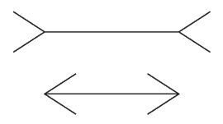

Which one is longer?

The two lines are the **same length**.

False application of the law of size constancy: top line appears like a concave edge, bottom like a convex edge. Former therefore seems further away than the latter and is therefore scaled to appear larger.

1. **How human realize the size, color, brightness and depth of a visual image?**

* **Size and depth:**
  + visual angle indicates how much of view object occupies  
     (relates to size and distance from eye)
  + visual acuity is ability to perceive detail.
  + familiar objects perceived as constant size   
     (in spite of changes in visual angle when far away)
  + cues like overlapping help perception of size and depth

The visual angle indicates how much of the field of view is taken by the object. The visual angle measurement is given in either degrees or *minutes of arc, where 1 degree is equivalent to 60 minutes of arc,* and 1 minute of arc to 60 seconds of arc.

* **Brightness:**
  + subjective reaction to levels of light
  + affected by luminance of object
  + measured by just noticeable difference
  + visual acuity increases with luminance as does flicker
* **Colour:**
  + made up of hue, intensity, saturation
  + cones sensitive to colour wavelengths
  + blue acuity is lowest
  + 8% males and 1% females colour blind

1. **What are the difference between deductive reasoning and abductive reasoning?**

|  |  |
| --- | --- |
| **Deductive reasoning** | **Abductive reasoning** |
| Derive logically necessary conclusion from given premises. | Reasoning from event to cause. |
| e.g. If it is Friday then she will go to work.  It is Friday therefore, she will go to work. | e.g. Sam drives fast when drunk.  If I see Sam driving fast, assume drunk. |
| When truth and logical validity clash:  e.g. Some people are babies.  Some babies cry.  Inference - Some people cry. | Unreliable: can lead to false explanations. |
| Logical conclusion not necessarily true:  e.g. If it is raining then the ground is dry.  It is raining therefore; the ground is dry. | Logical conclusion is necessarily true. |

1. **What are the mental models? Why are they important in interface design?**

**Mental Model:**

A **mental model** is an explanation of someone's thought process about how something works in the real world. It is a representation of the surrounding world, the relationships between its various parts and a person's intuitive perception about his or her own acts and their consequences.

Humans create mental models to explain behaviour. If wrong (different from actual system) errors can occur.

**Why Mental Models are important in interface design:**

1. Mental models are representations of systems and environments derived from experience.
2. People understand and interact with systems and environments by comparing the outcomes of their mental models with the real-world systems and environments.
3. When the outcomes correspond, a mental model is accurate and complete. When the outcomes do not correspond, the mental model is inaccurate or incomplete.
4. With regards to design there are two basics of mental models: mental models of how systems work (system models) and mental models of how people interact with systems (interaction models).
5. Designers generally have very complete and accurate models but often have weak interaction models-i.e. they know much about how a system works but little about how people will interact with the system.
6. Conversely users of a design tend to have sparse and inaccurate system models, but through use and experience commonly attain interaction models that are more complete and accurate than those of designers.
7. Optimal design results only when designers have an accurate and complete system model attain an accurate and complete interaction model and then design a system interface that reflects an efficient merging of both models.
8. Designers can obtain accurate and complete interaction models through personal use of the system, laboratory testing and direct observation of people interacting with the system or similar systems.
9. Use of the system by the designer will reveal obvious design problems but will fail to reveal the problems of interaction that emerge when people are unfamiliar with the system.
10. Laboratory testing is useful for evaluating designs in a controlled environment but most conducted with care as the artificial context and expectation effects can compromise the validity of the results.
11. Direct observation in the target environment is the preferred method for acquiring accurate information about how people interact with systems but is costly and impractical for designs that are not yet publicly available.
12. Design with people’s interaction model in mind. If there is a standard mental model for how something works, try to design leveraging that model.
13. When this is not possible create an interaction experience that draws from common mental models as much as possible such as the desktop metaphor for computers.
14. However, do not contrive design just to leverage a familiar model it is better to have people learn a new model that is clear and consistent than to use a familiar model that does not fit.
15. **Why do we need to study on human psychology in HCI?**

**Why psychology need to study in HCI:**

1. Human psychology is called cognitive psychology. One aspect of cognitive psychology affects on the use of computer system.
2. Psychology let us know how humans perceive the world around them.
3. Psychology let us know how humans store and process information and solve problems.
4. Psychology let us know how humans physically manipulate objects.
5. Some direct applications:

e.g. blue acuity is poor ⇒ blue should not be used for important detail

1. Correct application generally requires understanding of context in psychology, and an understanding of particular experimental conditions.
2. A lot of knowledge has been distilled in guidelines and cognitive models.
3. By studying psychology, we can learn about human experimental and analytic evaluation techniques.
4. Knowledge of the user’s perceptual, cognitive and problem-solving skills is need to know for an interactive design.

* So cognitive psychology closely related with designing and building interactive computer systems.

1. **What are the different types or error that a human can do? What do you mean by mental model?**

**Types of error:**

1. Slips:
   1. Right intention, but failed to do it right
   2. Causes: poor physical skill, inattention etc.
   3. Change to aspect of skilled behaviour can cause slip
2. Mistakes:
   1. Wrong intention
   2. Cause: incorrect understanding

**Mental Model:**

Humans create mental models to explain behaviour. If wrong (different from actual system) errors can occur. A **mental model** is an explanation of someone's thought process about how something works in the real world.

1. **How do you explain the “Interaction Paradigm”? What are the processes of paradigm shifting?**

Paradigm means predominant theoretical frameworks or scientific world views.

**Interaction Paradigm:**

New computing technologies arrive, creating a new perception of the human—computer relationship.

We can trace some of these shifts in the history of interactive technologies.

**Processes of paradigm shifting:**

* Batch processing
* Timesharing
* Networking
* Graphical display
* Microprocessor
* Word Wide Web
* Ubiquitous Computing

1. **Write the name of some pointing devices with their uses.**
2. **The mouse:**

* Handheld pointing device
* Very common
* Easy to use
* Two characteristics
* Planar movement
* Buttons

(Usually from 1 to 3 buttons on top, used for making a selection, indicating an option, or to initiate drawing etc.)

1. **Touchpad:**

* Small touch sensitive tablets
* ‘stroke’ to move mouse pointer
* Used mainly in laptop computers
* Good ‘acceleration’ settings important
* Fast stroke
  + Lots of pixels per inch moved
  + Initial movement to the target
* Slow stroke
  + Less pixels per inch
  + For accurate positioning

1. **Joystick:**

* Indirect pressure of stick
* Velocity of movement
* Buttons for selection on top or on front like a trigger
* Often used for computer games aircraft controls and 3D navigation

1. **Keyboard nipple:**

* for laptop computers
* miniature joystick in the middle of the keyboard

1. **Touch-sensitive screen:**

* Detect the presence of finger or stylus on the screen.
* Works by interrupting matrix of light beams, capacitance changes or ultrasonic reflections
* Direct pointing device

1. **Stylus:**

* Small pen-like pointer to draw directly on screen
* May use touch sensitive surface or magnetic detection
* Used in PDA, tablets pcs and drawing tables

1. **Light Pen:**

* Now rarely used
* Uses light from screen to detect location
* Very direct and obvious to use
* But can obscure screen

1. **Digitizing tablet:**

* Mouse like-device with cross hairs
* Used on special surface - rather like stylus
* Very accurate - used for digitizing maps

1. **Eye gaze:**

* Control interface by eye gaze direction
  + E.g. Look at a menu item to select it
* Uses laser beam reflected off retina
  + a very low power laser!
* Mainly used for evaluation (ch x)
* Potential for hands-free control
* High accuracy requires headset
* Cheaper and lower accuracy devices available
* Sit under the screen like a small webcam

1. **Cursor keys:**

* Four keys (up, down, left, right) on keyboard.
* Very, very cheap, but slow.
* Useful for not much more than basic motion for text-editing tasks.
* No standardised layout, but inverted “T”, most common

1. **Discrete positioning controls:**

* In phones, TV controls etc.
* cursor pads or mini-joysticks
* discrete left-right, up-down
* mainly for menu selection

1. **What are the elements of WIMP interface?**

The elements of WIMP interface are:

* + 1. Windows
    2. Icons
    3. Menus
    4. Pointers

Or,

1. Windows
2. Icons
3. Mice
4. Pull-down menus

These are default style for majority of interactive computer systems, especially PCs and desktop machines. More elements: buttons, toolbars, palettes, dialog boxes.

1. **What are the seven stages of Donald Norman’s Model?**

**Seven stages of Donald Norman’s model:**

1. User establishes the goal
2. Formulates intention
3. Specifies actions at interface
4. Executes action
5. Perceives system state
6. Interprets system state
7. Evaluates system state with respect to goal

Norman’s model concentrates on user’s view of the interface:



Fig: Normans model

1. **What do you mean by ergonomics in context of HCI?**

**Ergonomics in context of HCI:**

* Study of the **physical characteristics** of interaction
* Also known as **human factors** – but this can also be used to mean much of HCI!
* Ergonomics good at defining **standards and guidelines** for constraining the way we design certain aspects of systems.
* Arrangement of controls and displays

E.g. Controls grouped according to function or frequency of use, or sequentially

* Surrounding environment

E.g. Seating arrangements adaptable to cope with all sizes of user

* Health issues

E.g. Physical position, environmental conditions (temperature, humidity), lighting, noise,

* Use of colour

E.g. Use of red for warning, green for okay, awareness of colour-blindness etc.

1. **Discuss different types of interaction style?**

**Common Interaction Style:**

* Command line interface
* Menus
* Natural language
* Question/answer and query dialogue
* Form-fills and spreadsheets
* WIMP
* Point and click
* Three–dimensional interfaces

1. **What is the difference between error and slip?**

|  |  |
| --- | --- |
| **Error** | **Slip** |
| Wrong intention | Right intention but failed to do it right. |
| Cause: incorrect understanding. | Causes: poor physical skill, inattention etc. |
| Wrong understanding can cause error. | Change to aspect of skilled behaviour can cause slip. |
| Condition of having incorrect or false knowledge. | Failure to utilize a known system correctly. |
| Cannot be recognized by the learner. | Speaker can recognize. |
| An error cannot be self-corrected. | Speaker can correct it. |
| It reveals a portion of the learner’s competence in the L2. | It is not a deficiency in competence. |
| Understand system and goal. | May not even know the right goal. |

1. **Describe the steps of process design.**

**The steps of process design:**

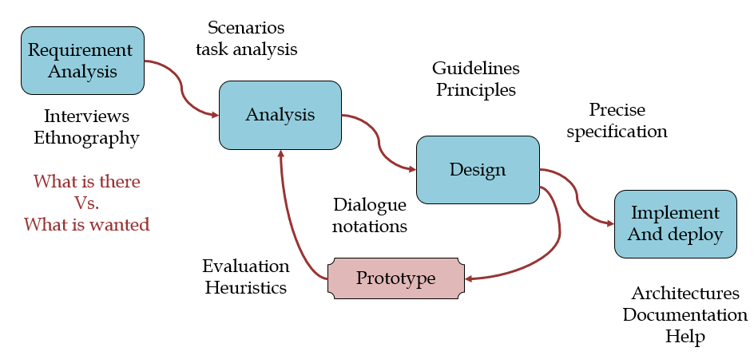

Fig: steps of process design

1. **What is prototyping in software design? What are the pitfalls in prototyping?**

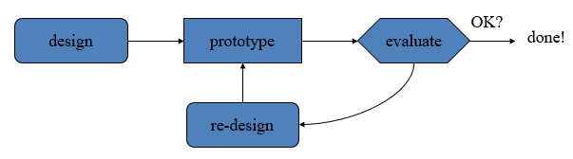

Fig: prototyping in software design

* **Prototyping in software design:**

Prototypes are experimental and incomplete designs which are cheaply and fast developed. Prototyping, which is the process of developing prototypes, is an integral part of iterative user-centered design because it enables designers to try out their ideas with users and to gather feedback.

* **Pitfalls:**

1. Moving little by little … but to where
2. Malvern’s or the Matterhorn?
3. Diving into the First Good Idea
4. Falling in Love with Your Prototypes
5. Wasting Time Explaining and Pitching
6. Prototyping Without a Purpose
7. Need a good start point
8. Need to understand what is wrong
9. The Failure Roadblock: Feeling Discouraged by Failed Prototypes
10. **What do you mean by software life cycle?**

**Software life cycle:**

The software life cycle refers to all the phases of a software product throughout its planning, development, and use, all the way through to its eventual obsolescence or retirement. This helps developers and others to understand how a product is created, implemented and used. Software engineering is the discipline for understanding the software design process, or life cycle.

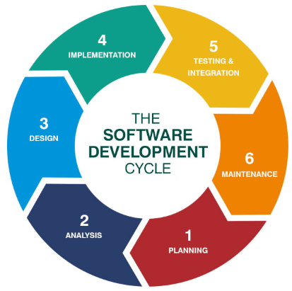

Fig: software life cycle

1. **What is usability engineering?**

**Usability Engineering:**

* Usability engineering is used to determine to what degree a product or prototype will be user-friendly.
* Usability engineering requires a firm knowledge of computer science and psychology and approaches product development based on customer feedback.
* A usability engineer works hand-in-hand with customers, working to develop a better understanding of the functionality and design requirements of a product in order to build more reliable data for it.

There are six general attributes define usability: (ISO usability standard 9241)

* + Utility
  + Learn-ability
  + Efficiency
  + Retain-ability
  + Errors
  + Customer satisfaction

1. **Write on gIBIS and design space analysis.**

* **gIBIS:**

Graphical Issue-Based Information System. gIBIS is a graphical version of IBIS. This is a hypertext tool for team design deliberation.

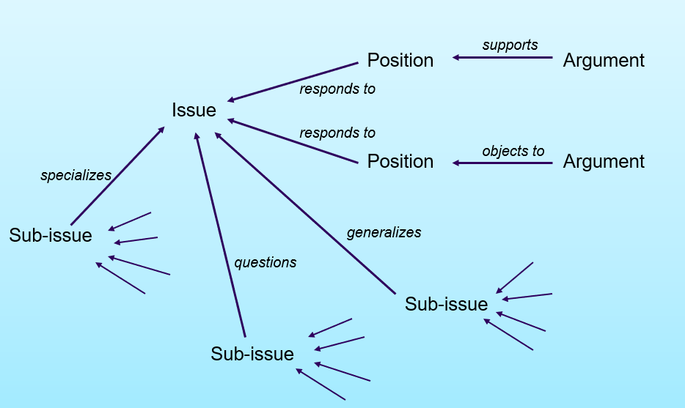

Fig: gIBIS structure

* **Design space analysis:**

A more deliberative approach to design rationale which emphasizes a post hoc structuring of the space of design alternatives that have been considered in a design project. This approach, embodied in the Questions, Options and Criteria (QOC) notation, is characterized as design space analysis.

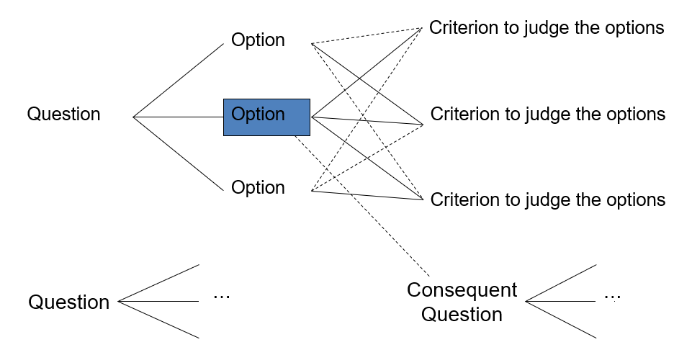

Fig: design space analysis

1. **Define the terms sensor-based and context-aware interaction.**

**Sensor-based and Context-aware Interaction:**

* Humans are good at recognizing the “context” of a situation and reacting appropriately
* Automatically sensing physical phenomena (e.g., light, temp, location, identity) becoming easier
* How can we go from sensed physical measures to interactions that behave as if made “aware” of the surroundings?

1. **What is design rationale? List different types of DR. Write the benefits of DR.**

* **Design rationale:**

Is information that explains why a computer system is the way it is, including its

-structural and architectural design

-its functional and behavioural description

* **Types of DR:**

1. **Process-oriented:** preserves order of deliberation and decision-making. provides a historical record of design decisions.
2. **Structure-oriented:** Concern with the structure of the space of all design alternatives, which can be reconstructed by post hoc consideration of the design activity.

* **Benefits of design rationale:**

1. **Communication throughout life cycle:** Design rationale provides a communication mechanism among the members of a design team so that during later stages of design and/or maintenance it is possible to understand what critical decisions were made, what alternatives were investigated and the reason why one alternative was chosen over the others.
2. **Reuse of design knowledge across products:** Accumulated knowledge in the form of design rationales for a set of products can be reused to transfer what has worked in one situation to another situation which has similar needs.
3. **Enforces design discipline:** Forces the designer to deliberate more carefully about design decisions.
4. **Presents arguments for design trade-offs:** There is usually no single best design alternative. More often, the designer is faced with a set of trade-offs between different alternatives.
5. **Organizes potentially large design space:** Even if an optimal solution did exist for a given design decision, the space of alternatives is so vast that it is unlikely a designer would discover it.
6. **Capturing contextual information:** The usability of an interactive system is very dependent on the context of its use. The flashiest graphical interface is of no use if the end-user does not have access to a high-quality graphics display or a pointing device.
7. **Reuse of design knowledge across products**: Accumulated knowledge in the form of design rationales for a set of products can be reused to transfer what has worked in one situation to another situation which has similar needs.
8. **Enforces design discipline:** Forces the designer to deliberate more carefully about design decisions.
9. **Presents arguments for design trade-offs:** There is usually no single best design alternative. More often, the designer is faced with a set of trade-offs between different alternatives.
10. **Organizes potentially large design space:** Even if an optimal solution did exist for a given design decision, the space of alternatives is so vast that it is unlikely a designer would discover it.
11. **Capturing contextual information:** The usability of an interactive system is very dependent on the context of its use. The flashiest graphical interface is of no use if the end-user does not have access to a high-quality graphics display or a pointing device.
12. **What is the main element of issue-based information system (IBIS)? Draw the hierarchical structure of gIBIS.**

**Main elements of IBIS:**

* **Issues**– Hierarchical structure with one ‘root’ issue
* **Positions**– Potential resolutions of an issue
* **Arguments**– Modify the relationship between positions and issues

**Hierarchical structure of gIBIS:**



Fig: gIBIS structure

1. **What are differences between interactions and interventions?**

**Interactions:** Design interactions not just interfaces, not just the immediate interaction.

* + e. g. Stapler in office – technology changes interaction style
* Manual: write, print, staple, write, print, staple…
* Electric: write, print, write print, …., staple

**Interventions:** Designing interventions not just artefacts, not just the system, but also …

* + - Documentation, manuals, tutorials
    - What we say and do as well as what we make

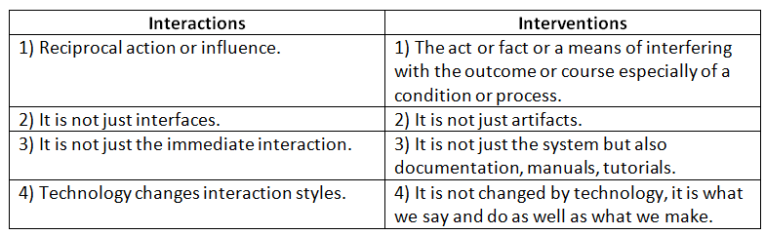

1. **What do you mean by software life cycle? Draw the waterfall model for software lifecycle?**

**Software life cycle:**

The software life cycle refers to all the phases of a software product throughout its planning, development, and use, all the way through to its eventual obsolescence or retirement. This helps developers and others to understand how a product is created, implemented and used. Software engineering is the discipline for understanding the software design process, or life cycle.

**The waterfall model:**

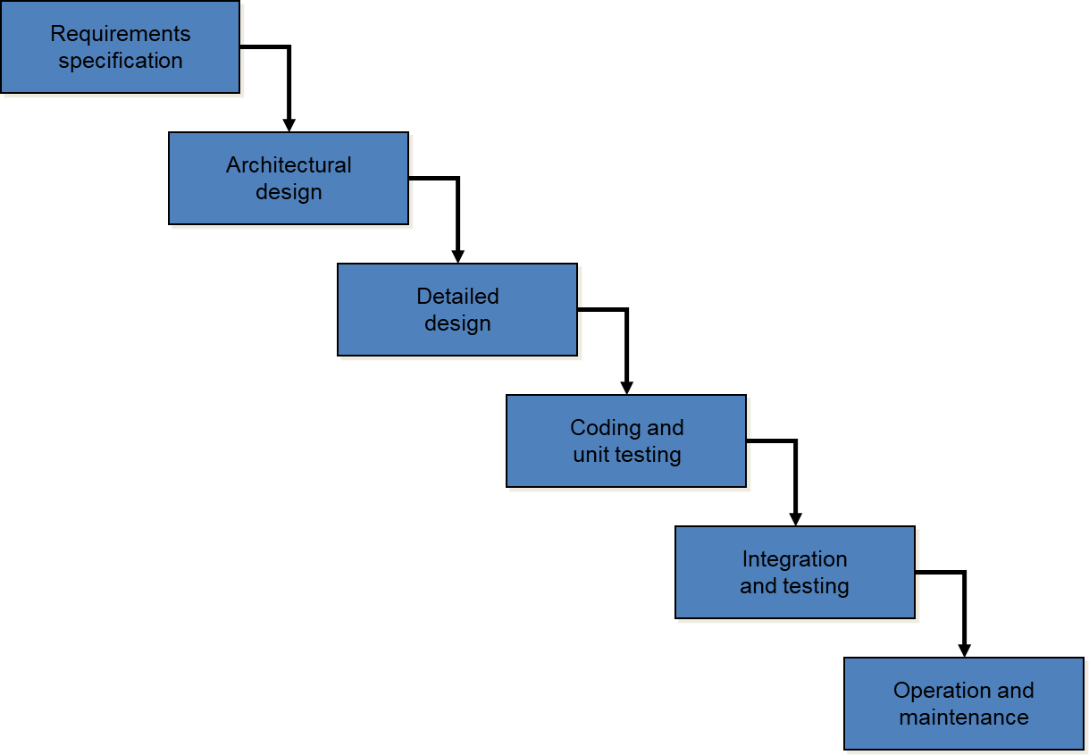

Fig: the waterfall model

1. **What are the six general attributes that define usability.**

There are six general attributes define usability: (ISO usability standard 9241)

* 1. Utility
  2. Learn-ability
  3. Efficiency
  4. Retain-ability
  5. Errors
  6. Customer satisfaction